**Project Design Phase-II**

**Data Flow Diagram & User Stories**

|  |  |
| --- | --- |
| Date | 03 August 2025 |
| Team ID | LTVIP2025TMID59168 |
| Project Name | SmartSDLC – AI-Enhanced Software Development Lifecycle |
| Maximum Marks | 4 Marks |

**Data Flow Diagrams:**

A Data Flow Diagram (DFD) is a traditional visual representation of the information flows within a system. A neat and clear DFD can depict the right amount of the system requirement graphically. It shows how data enters and leaves the system, what changes the information, and where data is stored.

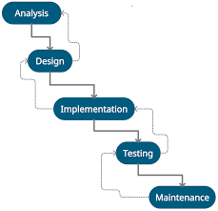 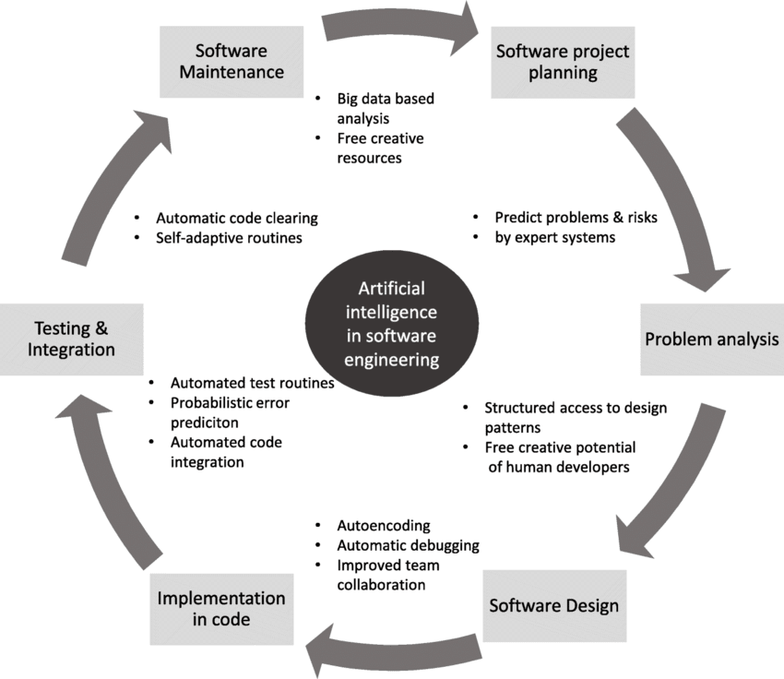

**User Stories**

Use the below template to list all the user stories for the product.

|  |  |  |  |  |  |  |
| --- | --- | --- | --- | --- | --- | --- |
| User Type | Functional Requirement (Epic) | User Story Number | User Story / Task | Acceptance Criteria | Priority | Release |
| Developer | Requirement Classification | USN-1 | As a developer, I can upload software requirements to get them auto-classified. | Requirements are shown as Functional, Non-Functional, or UI. | High | Sprint-1 |
| Developer | Requirement Classification | USN-2 | As a developer, I can view categorized results from the uploaded text. | Output displays classification tags clearly. | High | Sprint-1 |
| Developer | Bug Fixing AI | USN-3 | As a developer, I can paste buggy code to receive AI-suggested corrections. | Corrected code is displayed alongside the original. | High | Sprint-1 |
| Developer | Bug Fixing AI | USN-4 | As a developer, I can download or copy the fixed code from the output panel. | Fixed code can be copied or downloaded successfully. | Medium | Sprint-1 |
| Developer | Code Generation | USN-5 | As a developer, I can input a plain-text requirement and receive generated code. | Code is generated in Python and displayed in editor. | High | Sprint-2 |
| Developer | Code Generation | USN-6 | As a developer, I can download the generated code for further use. | Generated code is downloadable as a .py file. | Medium | Sprint-2 |
| End User (Web) | Dashboard UI | USN-7 | As a user, I can interact with SmartSDLC features via a Streamlit dashboard. | UI is clean and all features are clickable and functional. | High | Sprint-2 |
| End User (Web) | Deployment | USN-8 | As a user, I can access the application via a public ngrok link without setup. | Platform runs via link with full functionality. | Medium | Sprint-2 |
| Admin | Feedback & Monitoring | USN-9 | As an admin, I can view feedback submitted by users about the platform. | Feedback is stored and viewable in dashboard. | Low | Sprint-3 |